DATE: 19.07.2019
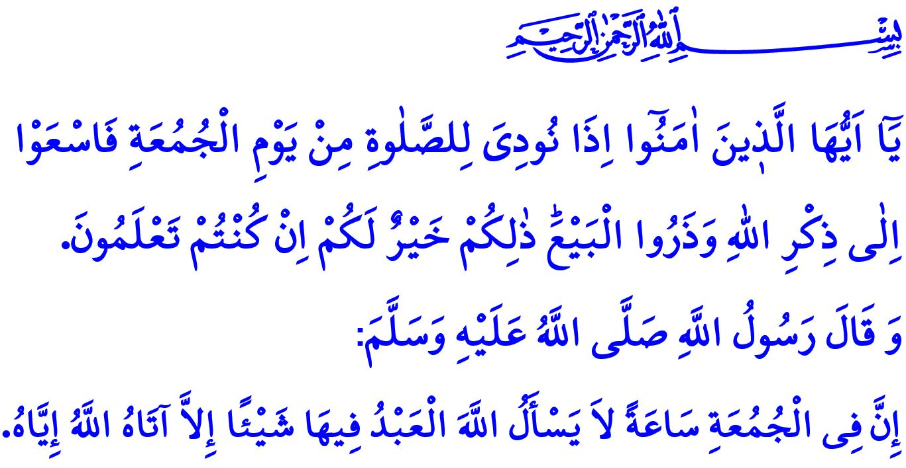
FRIDAY PRAYER AND ITS CUSTOMS
Honorable Muslims!
Today is Friday. The most blessed and bountiful day of a week. Today is an eid of Believers and a time of meeting weekly. It is an occasion of grace and mercy and brotherhood and familiarity.
It is a unique spiritual climate that differs from the other days in terms of its value and merit. The Prophet Muhammad (saw) told us about Friday, “The best day on which the sun rises is Friday. [On Friday] Adam was created, and on that day he entered Paradise, and on that day he was expelled from Paradise. And the Hour will come to pass on Friday.”
Dear Believers!
Today, our most important responsibility is to perform the Friday prayer. Because Friday prayer is an obligation for Muslims. The Almighty Allah (swt) states in the verse I recited in the beginning of my khutbah, “O ye who believe! When the call is proclaimed to prayer on Friday (the day of assembly), hasten earnestly to the remembrance of Allah, and leave off business (and traffic): That is best for you if ye but knew!”
Neglecting Friday prayer unless there is a valid excuse is a great sin. The Messenger of Allah (saw) warned us about this issue, “Whoever do not establish Friday prayer three times because he does not care about it, Allah sets a seal on his heart.”
Honorable Muslims!
Every believer who wants to benefit from the baraqah of Friday prepares himself for Friday prayer by complying with the sunnah of our Prophet Muhammad (saw). He performs ablution properly and cleans his body. He makes a point of wearing clothes that are clean and suitable to satr-i awrat. He knows that it would not be good to come mosque after eating stinky food. He wears nice scents. He behaves in accordance with the soul of the worship and the awe of the community. He makes effort to close and align the ranks. He respects Friday prayer and avoids from making noise and disturbing the people who stand near him in the presence of Allah (swt).
Dear Muslims!
On this blessed day, another point we need to be careful about is the Friday khutbah. Khutbah is a call on ummah from minbar. It is a recommendation, reminder, and warning for Muslims. It is an invitation to iman, wisdom, and morals and a call for the truth. Khutbah is also a must of Friday prayer. Khutbah is a worship, too, just like prayers.
It a religious necessity to listen to the khatib in awe, silently and by hanging on his every word. Taking to your friends or playing with your phones during khutbah causes you to stray from the essence of khutbah and miss out the rewards of it. Sadly, I need to say that such behaviors that are contrary to the soul of worship are becoming widespread among our community day by day. However, the Prophet Muhammad (saw) did not even tolerate speaking of a member of community in order to warn a friend who speaks near him, and warned his ummah about this issue, “You are wrong even to say ‘’Hush!’’ to your friend while imam reads khutbah on Friday.”
Honorable Believers!
Let us try to benefit from the bounty and blessing of Friday that is the best day on which the sun rises. Let us conduce this day to meet, become friends, and strengthen our brotherhood bonds. To ask how we are doing, to share each other’s happiness, and to give hand to each other when one of us suffers. Let us look for ways to help the needy people, those who are short of money, and the ones who are in bad health. On Fridays, let us go mosques with all members of our family as it was in the Asr al-Saadah. Let us familiarize our children with Friday prayer and invite our young people to the presence of Friday.
Let us remember that khutbah is a part of the prayer. Let us give our interest and attention only to khatib and khutbah during the khutbah. Let us stay away from behaviors that do not suit to the soul of the worship. In this time of acceptance when duas are accepted let us our bodies, minds, hearts, and feelings turn to al-Rahman.
I would like to conclude my khutbah with these glad tidings of the Prophet Muhammad (saw), “There is such a moment on Friday that if servants ask something, Allah certainly bestows what they ask to them.”

Muslim, Jumu’ah, 18.
Jumu’ah, 62/9.
Ibn Majah, Ikamet, 93.
Muslim, Jumu’ah, 11.
Tirmidhi, Jumu’ah, 2. General Directorate of Religious Affairs

